Republic of the Philippines
Department Of Education
Region III – Central Luzon
SCHOOLS DIVISION OF SAN JOSE DEL MONTE CITY
District 10
FRANCISCO HOMES ELEMENTARY SCHOOL
Francisco Homes - Narra, San Jose del Monte City 3023

website: depedfranciscohomeses.weebly.com / e-mail address: 107154.sjdmc@deped.gov.ph

February 07, 2020
School Memorandum
No. 4, s. 2020

To: ALL FHES TEACHERS
HEAD TEACHER

SCHOOL CHECKING OF SCHOOL FORMS FOR S.Y. 2019-2020

1. This office announces the conduct of School Checking of School Forms of Kindergarten, Grade 1-5 and Grade 6 which shall be held in the following dates:

GRADE LEVEL | DATE | NAME OF TEACHER
Grade VI | February 26, 2020 (a.m.) | Merly R. Indaya
Grade VI | February 26, 2020 (p.m.) | Edielynjoy Taccaban
Grade VI | February 27, 2020 (a.m.) | Nerissa R. Masirag
Grade VI | February 27, 2020 (p.m.) | Jane A. Mangahas
Grade VI | February 28, 2020 (a.m.) | Janet F. Villasana
Grade VI | February 28, 2020 (p.m.) | Fe W. Albacite
Grade VI | March 2, 2020 (a.m.) | Aiza B. Arganda
Grade VI | March 2, 2020 (p.m.) | Susana M. Indaya
Kindergarten | March 3, 2020 (a.m.) | Patty B. Fajardo
Kindergarten | March 3, 2020 (p.m.) | Florcel Ann A. Mendoza
Grade VI | March 3, 2020 (a.m.) | Flordeliza J. Arado
Grade VI | March 3, 2020 (p.m.) | Melinda D. Diaz
Kindergarten | March 4, 2020 (a.m) | Catherine A. Bautista
Kindergarten | March 4, 2020 (p.m.) | Herley F. Bantigue
Grade VI | March 4, 2020 (a.m.) | Lorna B. Gacutan
Grade VI | March 4, 2020 (p.m.) | Sherille P. Punzalan
Kindergarten | March 5, 2020 (a.m.) | Marjorie A. Bolaños
Kindergarten | March 5, 2020 (p.m.) | Girlie R. Ruffy
Grade VI | March 5, 2020 (p.m.) | Paul N. Aquino
Kindergarten | March 6, 2020 (a.m.) | Eva Ruth C. Dyangco
Kindergarten | March 6, 2020 (p.m.) | Emee O. Sodela
Grade 1 | March 9-10, 2020 | Grade 1 Teachers
Grade 2 | March 11-12, 2020 | Grade 2 Teachers
Grade 3 | March 13 & 16, 2020 | Grade 3 Teachers
Grade 4 | March 17-18, 2020 | Grade 4 Teachers
Grade 5 | March 19-20, 2020 | Grade 5 Teachers

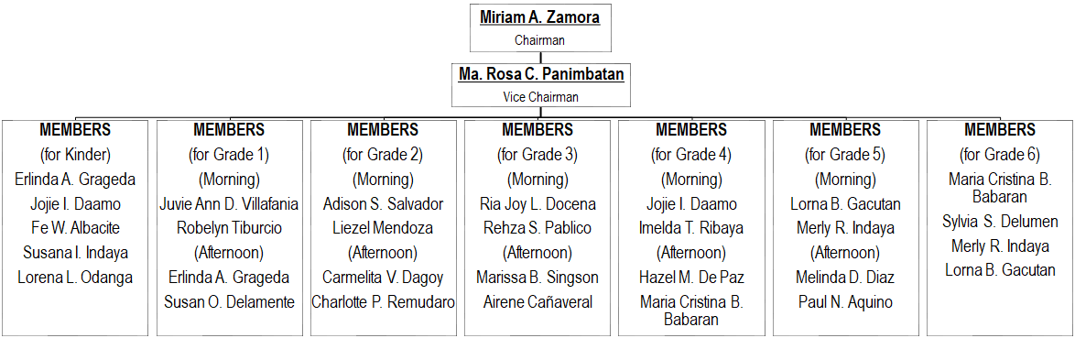
2. School Checking Committee are as follows:

3. For information and wide dissemination.

MIRIAM A. ZAMORA
Principal III

