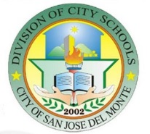
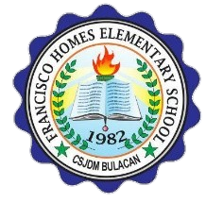
Republic of the Philippines
Department Of Education
Region III – Central Luzon
SCHOOLS DIVISION OF SAN JOSE DEL MONTE CITY
District 10
FRANCISCO HOMES ELEMENTARY SCHOOL
Francisco Homes - Narra, San Jose del Monte City 3023

website: depedfranciscohomeses.weebly.com / e-mail address: 107154.sjdmc@deped.gov.ph

January 10, 2020
School Memorandum
No. 2, s. 2020

To: ALL FHES TEACHERS
HEAD TEACHER

SCHOOL INSPECTION TEAM

- Pursuant to RA 9184 otherwise known as the Government Procurement Reform Act for the purpose of prescribing the necessary rules and regulations for the modernization, standardization and regulation of the procurement and inspection activities of the government by the Philippines and

- In order to facilitate the smooth implementation of the various projects of the Department, the complete Inspectorate Team is hereby created:

Composition of the Inspectorate Team
School-Based Feeding Program

Chairperson: Divina Gracia T. Mawili
Members: Rufino E. Mabingnay
Erlinda A. Grageda
May Anne N. Delamente

- Wide dissemination of this school memorandum is highly expected.

MIRIAM A. ZAMORA
Principal III

